

**YUKTI - National Innovation Repository**

|  |  |
| --- | --- |
| **Idea / Proof of Concept (PoC)** | Yes |
| **Innova**ti**on / Prototype** | Yes |

MediMind: A Comprehensive Health Prediction and Record Keeping Platform

**\*Developed as part of**

|  |  |
| --- | --- |
|  | Yes |
| No |
| No |

**\*Choose the Financial Year, during the Idea-PoC/Innovation Developed – 2023**

**\*Sector / Domain**

|  |  |
| --- | --- |
| Agriculture & Rural Development. | **No** |
| Clean & Potable water. | No |
| Consumer Goods and Retail | No |
| Defence & Security | No |
| Education | No |
| Fashion and Textiles | No |
| Finance Life Sciences | No |
| Food Processing/Nutrition/Biotech | No |
| Healthcare & Biomedical devices. | Yes |
| ICT, cyber-physical systems, Blockchain, Cognitive computing, Cloud computing, AI & ML. | Yes |
| Infrastructure | No |
| IoT based technologies (e.g. Security & Surveillance systems etc) | No |
| Manufacturing | No |
| Mining, Metals, Materials | No |
| Other Emerging areas Innovation for Startrup | No |
| Renewable and affordable Energy. | No |
| Robotics and Drones. | No |
| Smart Cities | Yes |
| Smart Education | No |
| Smart Textiles | No |
| Smart Vehicles/ Electric vehicle/ Electric vehicle motor and battery technology. | No |
| Software - Mobile App Development | No |
| Software - Web App Development | Yes |
| Sports & Fitness | No |
| Sustainable Enviroment | No |
| Travel & Tourism | No |
| Waste Management/Waste to Wealth Creation | No |

**\*Innovation Type:**

|  |  |
| --- | --- |
| **Product** | **Yes** |
| **Process** | **Yes** |
| **Service** | **Yes** |
| **Market Place** | **Yes** |
| **Business/Management Innovation** | **Yes** |

**\* Development Stage - Technology Maturity of the Solution/Innovation in terms of Technology Readiness Level TRL (if applicable) – TRL Level:**

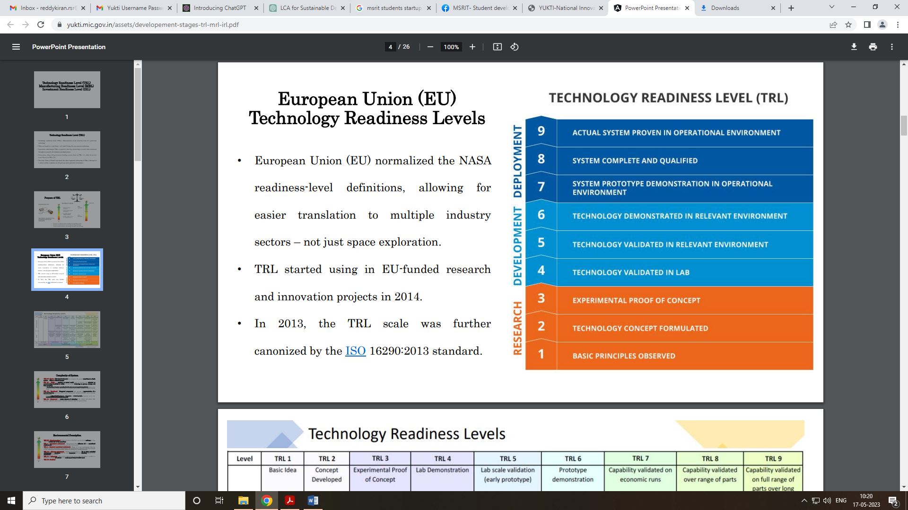

**Define the problem and its relevance to today's market / society / industry need (Max: 100 Words)**

|  |
| --- |
| The problem addressed by MediMind is the need for personalized healthcare management and early detection of diseases. In today's market and society, there is a growing demand for healthcare solutions that leverage advanced technologies to improve patient outcomes and reduce healthcare costs. MediMind's ability to analyze patient data, predict potential health issues, and provide personalized recommendations aligns with the industry's focus on data-driven healthcare. It addresses the market's need for efficient record-keeping, accurate disease prediction, and improved decision-making, ultimately contributing to better healthcare outcomes and enhancing the overall quality of patient care**.** |

**\*Describe the Solution / Proposed / Developed (Max: 100 Words)**

|  |
| --- |
| MediMind is an advanced healthcare platform that integrates record-keeping, prediction models, and personalized healthcare management. It utilizes machine learning algorithms to analyze patient data and predict potential health issues, focusing on skin diseases, diabetes, and heart disease. The platform provides a user-friendly interface for easy access and clear feedback. MediMind ensures data security and compliance with healthcare regulations. Its scalability allows customization for healthcare organizations of any size. Overall, the solution streamlines healthcare processes, enhances decision-making, and improves patient outcomes through personalized and data-driven healthcare management. |

**\*Explain the uniqueness and distinctive features of the (product / process / service) solution (Max: 100 Words)**

|  |
| --- |
| The MediMind platform stands out with its unique features and distinctive offerings. It combines comprehensive record-keeping, advanced machine learning algorithms, and specialized modules for skin disease, diabetes, and heart disease prediction. Its user-friendly interface ensures ease of use, while robust data privacy and security measures safeguard sensitive patient information. The platform's scalability allows it to cater to healthcare organizations of all sizes. What sets MediMind apart is its holistic and personalized approach to healthcare management, empowering individuals with data-driven insights and facilitating improved health outcomes. |

**\*How your proposed / developed (product / process / service) solution is different from similar kind of product by the competitors if any (Max: 100 Words)**

|  |
| --- |
| The proposed MediMind platform distinguishes itself from similar products by its comprehensive approach to healthcare management. While there may be competing solutions that focus on specific aspects such as disease prediction or patient record storage, MediMind integrates multiple functionalities into a single platform. It offers a combination of patient record storage, disease prediction using advanced algorithms, personalized healthcare management, and a user-friendly interface. This holistic approach sets it apart from competitors and provides healthcare organizations with a comprehensive solution that streamlines their operations and improves patient care. |

**\*Is there any IP or Patentable Component associated with the Solution?**

**Not Applicable**

**\*Has the Solution Received any Innovation Grant/Seed fund Support?**

**No**

**\*Are there any Recognitions (National/International) Obtained by the Solution? No**

**\*Upload the Copy of Latest Achievement: (JPG, PNG, PDF max 2 MB)**

**Softcopy of the Achievements. (Copy and Paste here)**

**\*Is the Solution Commercialized either through Technology Transfer or Enterprise Development/Startup? No**

**\*Had the Solution Received any Pre-Incubation/Incubation Support? No**

**Video URL: Images slideshow video or any short video.**

**Email the video file to** [**rrskiran@msrit.edu**](mailto:rrskiran@msrit.edu) **along with report.**

**Upload Photograph: (JPG, PNG, PDF max 2 MB) – Copy and paste Photographs**

**MRL Level Applicability – Yes**

MRL 1: Basic manufacturing implications identified

MRL 2: Manufacturing concepts identified

MRL 3: Manufacturing proof of concept developed

MRL 4: Capability to produce the technology in a laboratory environment

MRL 5: Capability to produce prototype components in a production relevant environment

MRL 6: Capability to produce a prototype system or subsystem in a production relevant environment

MRL 7: Capability to produce systems, subsystems or components in a production representative environment.

MRL 8: Pilot line capability demonstrated. Ready to begin low rate production.

MRL 9: Low rate production demonstrated. Capability in place to begin Full Rate Production.

MRL 10: Full rate production demonstrated and lean production practices in place.

**IR Level Applicability – No**

IRL 1: Basic Research (Need Identification & Peer Review Publications) & Completed First-Pass Business Model Canvas (BMC)

IRL 2: Applied Research (Market Size and Competitive Analysis) & Business Plan – Value Proposition & IP Identification

IRL 3: Validate Problem - Solution Fit (Confirmed Value Proposition & Techno-Economic Analysis) & Minimum Product Cost (Maturity of Core Technology)

IRL 4: Prototype Low-Fidelity Minimum Viable Product (MVP): “Low-fidelity” - A representative of the component or system that has limited ability to provide anything but initial information about the end product.

IRL 5: Validate Product-Market Fit (Integrated Validation of the Minimum Viable Process and Process Engineering). “High-fidelity” - A high-fidelity laboratory environment would involve testing with equipment that can simulate and validate all system specifications within a laboratory setting.

IRL 6: Validate Business/Revenue Model: Integrated Pilot Development– understanding operational nuances

IRL 7: Prototype High Fidelity MVP: Integrated Pilot Continuous Operation

IRL 8: Pre-Commercial Demonstration – Operating Conditions and quality stabilized

IRL 9: Full Commercial Development – A full time process engineering staff continuously verifies that operations are meeting cost, yield and productivity targets.

**\*Had the Solution Received any Pre-Incubation/Incubation Support? No**

**\*Utility: Highlight the utility/value proposition (key benefits) aspects of the solution/innovation* (Max: 100 Words)**

|  |
| --- |
| The utility and value proposition of the MediMind platform lie in its ability to provide personalized healthcare, early detection and prevention of diseases, secure data management, improved decision-making, and scalability. By leveraging advanced algorithms and machine learning, MediMind offers accurate disease predictions, enabling early intervention and better health outcomes. The platform's secure data management ensures the protection of sensitive patient information. Healthcare providers benefit from comprehensive patient health records, empowering them to make informed decisions and provide better treatment plans. Furthermore, MediMind's scalability and adaptability cater to the needs of healthcare organizations of all sizes, improving efficiency and reducing costs. |

**\*Scalability: Highlight the market potential aspects of the Solution/Innovation (Potential Market Size, segmentation and Target users/customers etc.) (Max: 100 Words)**

|  |
| --- |
| The market potential of MediMind is significant, considering the increasing demand for personalized healthcare solutions. The potential market size includes healthcare organizations, hospitals, clinics, and individual healthcare providers. The solution can be segmented based on the target users/customers, such as doctors, nurses, medical staff, and patients. MediMind caters to the needs of both large healthcare organizations and smaller clinics, making it scalable and adaptable to different market segments. With the rising adoption of digital health technologies and the focus on improving patient outcomes, there is a growing market for innovative platforms like MediMind that offer advanced data-driven healthcare solutions. |

**\*Economic Sustainability: Highlight commercialisation/business application aspects of the solution (how it is going to economic profitable and viable) (Max: 100 Words)**

|  |
| --- |
| MediMind has strong potential for economic sustainability and profitability. By providing healthcare organizations with an efficient and comprehensive platform for patient record-keeping, health prediction, and personalized healthcare management, MediMind can improve operational efficiency, reduce costs, and enhance patient outcomes. The platform can be monetized through subscription-based models, where healthcare organizations pay for access to the platform's features and services. Additionally, MediMind can generate revenue through partnerships and collaborations with pharmaceutical companies, medical device manufacturers, and telemedicine providers. The combination of cost savings, improved patient care, and revenue-generating opportunities makes MediMind an economically viable and profitable solution. |

**\*Environmental Sustainability: Highlight environmental friendliness aspects and related benefit of the solution/innovation  
(Max: 100 Words)**

|  |
| --- |
| While the primary focus of MediMind is on healthcare innovation, it indirectly contributes to environmental sustainability. By leveraging advanced algorithms and machine learning, MediMind can help healthcare providers make more accurate diagnoses, leading to optimized treatment plans and reduced healthcare waste. Through early detection and prevention of diseases, MediMind can contribute to the reduction of unnecessary medical procedures and resource consumption. Furthermore, by providing a platform for remote consultations and telemedicine, MediMind promotes virtual healthcare delivery, reducing the need for travel and minimizing carbon emissions associated with transportation. These environmental-friendly aspects align with the growing importance of sustainability and promote eco-conscious healthcare practices. |